**Student Handout**

**Environmental Justice Urban Air Pollution**

# **Engage**

# Write a few sentences expressing what you feel and think about when you see each image:

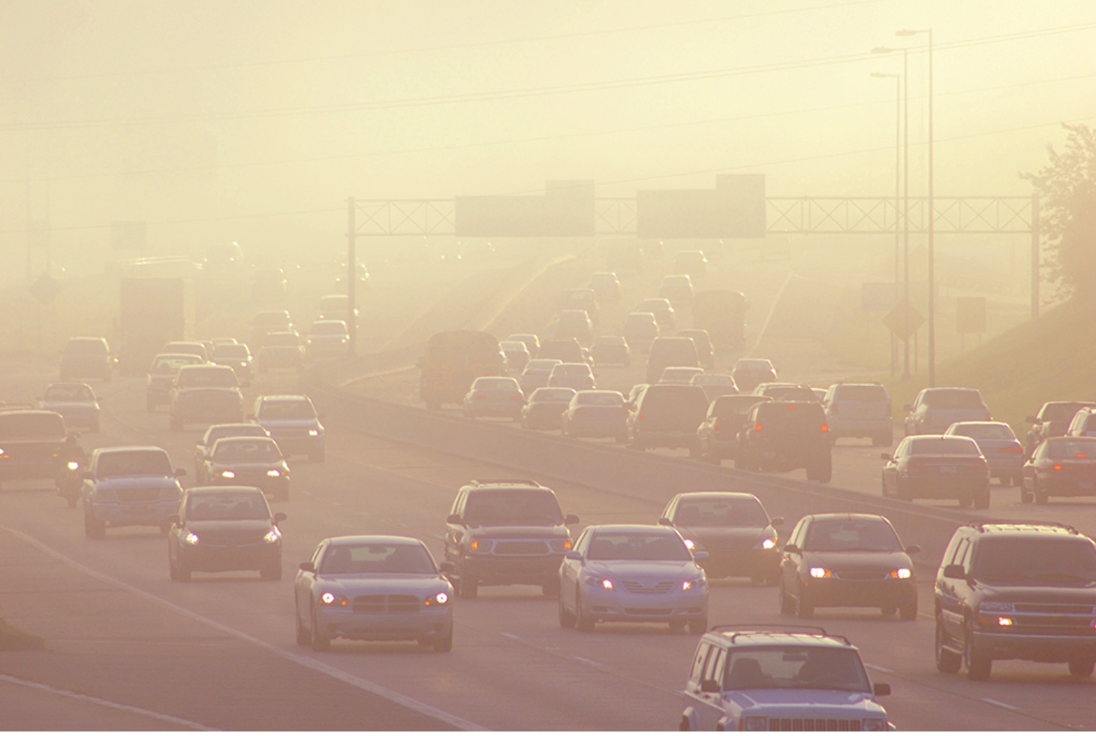

Image 1: ____________________________________________

__________________________________________________________________________________________________________________________________________________________________________________________________________________________________________________________________________________________________________________________________________________________________________________

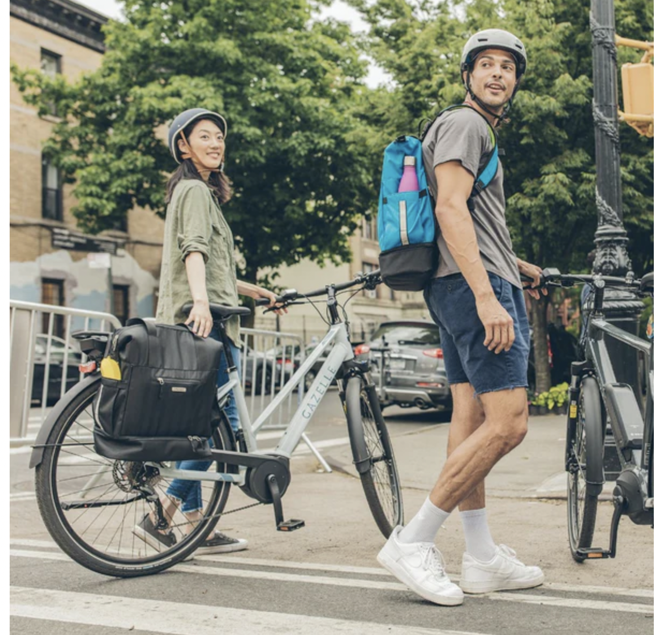

Image 2: ____________________________________________________

__________________________________________________________________________________________________________________________________________________________________________________________________________________________________________________________________________________________________________________________________________________________________________________

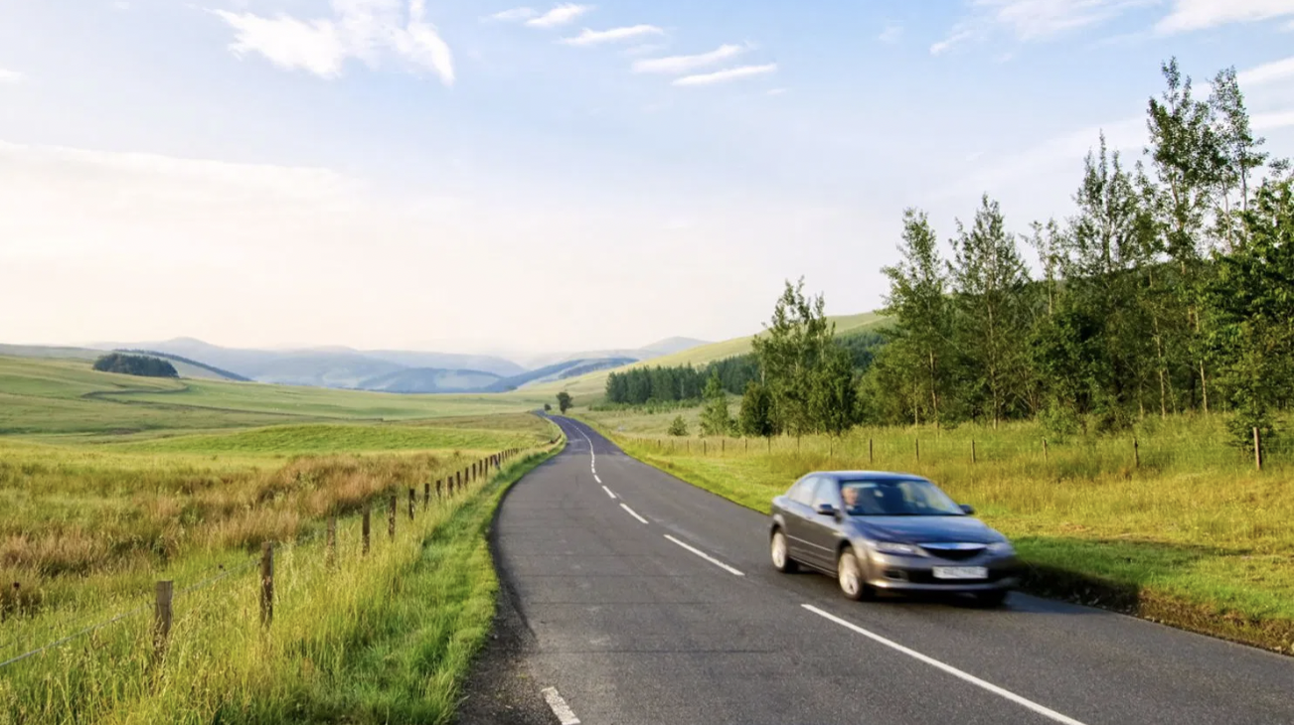

Image 3: __________________________________________

__________________________________________________________________________________________________________________________________________________________________________________________________________________________________________________________________________________________________________________________________________________________________________________

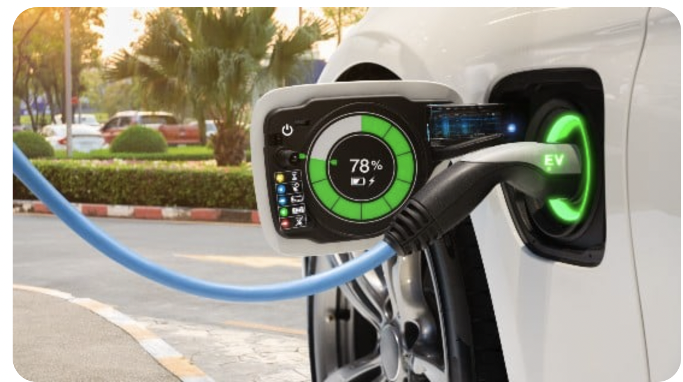

Image 4: _________________________________________

__________________________________________________________________________________________________________________________________________________________________________________________________________________________________________________________________________________________________________________________________________________________________________________

After seeing the word “AIR QUALITY”, answer the following questions:

a) Do you think the air quality in this area is good or bad?

______________________________________________________________________________________________________________________________________________________________________________________________________________________________

b) How do you know? What evidence is there of air pollution?

______________________________________________________________________________________________________________________________________________________________________________________________________________________________

c) Have you ever experienced burning eyes, itchy throat, or shortness of breath on polluted days?

______________________________________________________________________________________________________________________________________________________________________________________________________________________________

d) What time of the year does the air seem dirtiest?

______________________________________________________________________________________________________________________________________________________________________________________________________________________________

# **Introduction to Air Pollution**

As you watch the Air Pollution 101 YouTube video ([tinyurl.com/airpolution101](http://tinyurl.com/airpolution101)), answer the following questions:

1. What is air pollution?

____________________________________________________________________________________________________________________________________________________

1. What are the two main causes of air pollution?

____________________________________________________________________________________________________________________________________________________

1. What are the types of anthropogenic (human-made) air pollution?

____________________________________________________________________________________________________________________________________________________

**Types of Anthropogenic Pollution**

**Greenhouse Gas Definition:** Gasses that trap heat in the atmosphere.

Draw a preliminary model of what you think the greenhouse effect is.

**Creating a Model:**

1. In the space below, create a preliminary model for the greenhouse effect.

| **Model** |  |
| --- | --- |
| **Explanation** |  |

**Next, watch this video on Greenhouse gasses.** ([tinyurl.com/greenhouseeffectkhan](http://tinyurl.com/greenhouseeffectkhan))

**Revising the Model:**

1. Revise your previous model using the space below. Be sure that your model explains why and how the greenhouse gas effect works.

| **Model** |  |
| --- | --- |
| **Explanation** |  |

1. Name three examples of greenhouse gasses:
   1. _____________________________
   2. _____________________________
   3. _____________________________

**Smog:** Smog is air pollution that reduces visibility. The term "smog" was first used in the early 1900s to describe a mix of smoke and fog. The smoke usually came from burning coal.

As you watch the Science of Smog video ([tinyurl.com/scienceofsmog](http://tinyurl.com/scienceofsmog)), answer the following questions:

1. The burning of which fuel is the main source of industrial smog?

____________________________________________________________________________________________________________________________________________________

1. Define VOCs and PANs.

____________________________________________________________________________________________________________________________________________________

__________________________________________________________________________

1. Explain the difference between photochemical smog and industrial smog.

______________________________________________________________________________________________________________________________________________________________________________________________________________________________

**Toxic Air Pollutants:**

*Complete the sentences as you go over the slide deck.*

Toxic air pollutants are those pollutants that are known or suspected to cause cancer or other serious health effects, such as reproductive effects or birth defects, or adverse environmental effects.

Examples of toxic air pollutants include

* ______________, which is found in gasoline;
* ______________, which is emitted from some dry cleaning facilities; and
* ______________, which is used as a solvent and paint stripper by several industries.

# **Air Quality and Climate Change**

*Complete the sentences as you review the slide deck.*

**Impacts of Climate Change on Air Quality:**

Climate change exacerbates ____________________leading to increased frequency and intensity of_______________________________________ In addition, it can worsen local air quality, potentially leading to higher levels of ground-level ozone, which could pose challenges for meeting ozone standards in the future.

**Impacts of Air Quality on Climate Change**

Poor air quality contributes to ________________by releasing ____________ and aerosols. Emissions from burning fossil fuels and biomass increase atmospheric concentrations of carbon dioxide and other heat-trapping gasses, leading to global warming. Additionally, aerosols can affect cloud formation and alter the planet's energy balance.

*Using the picture below, explain in your own words at least two interactions. You may use a Google search to do further research.*

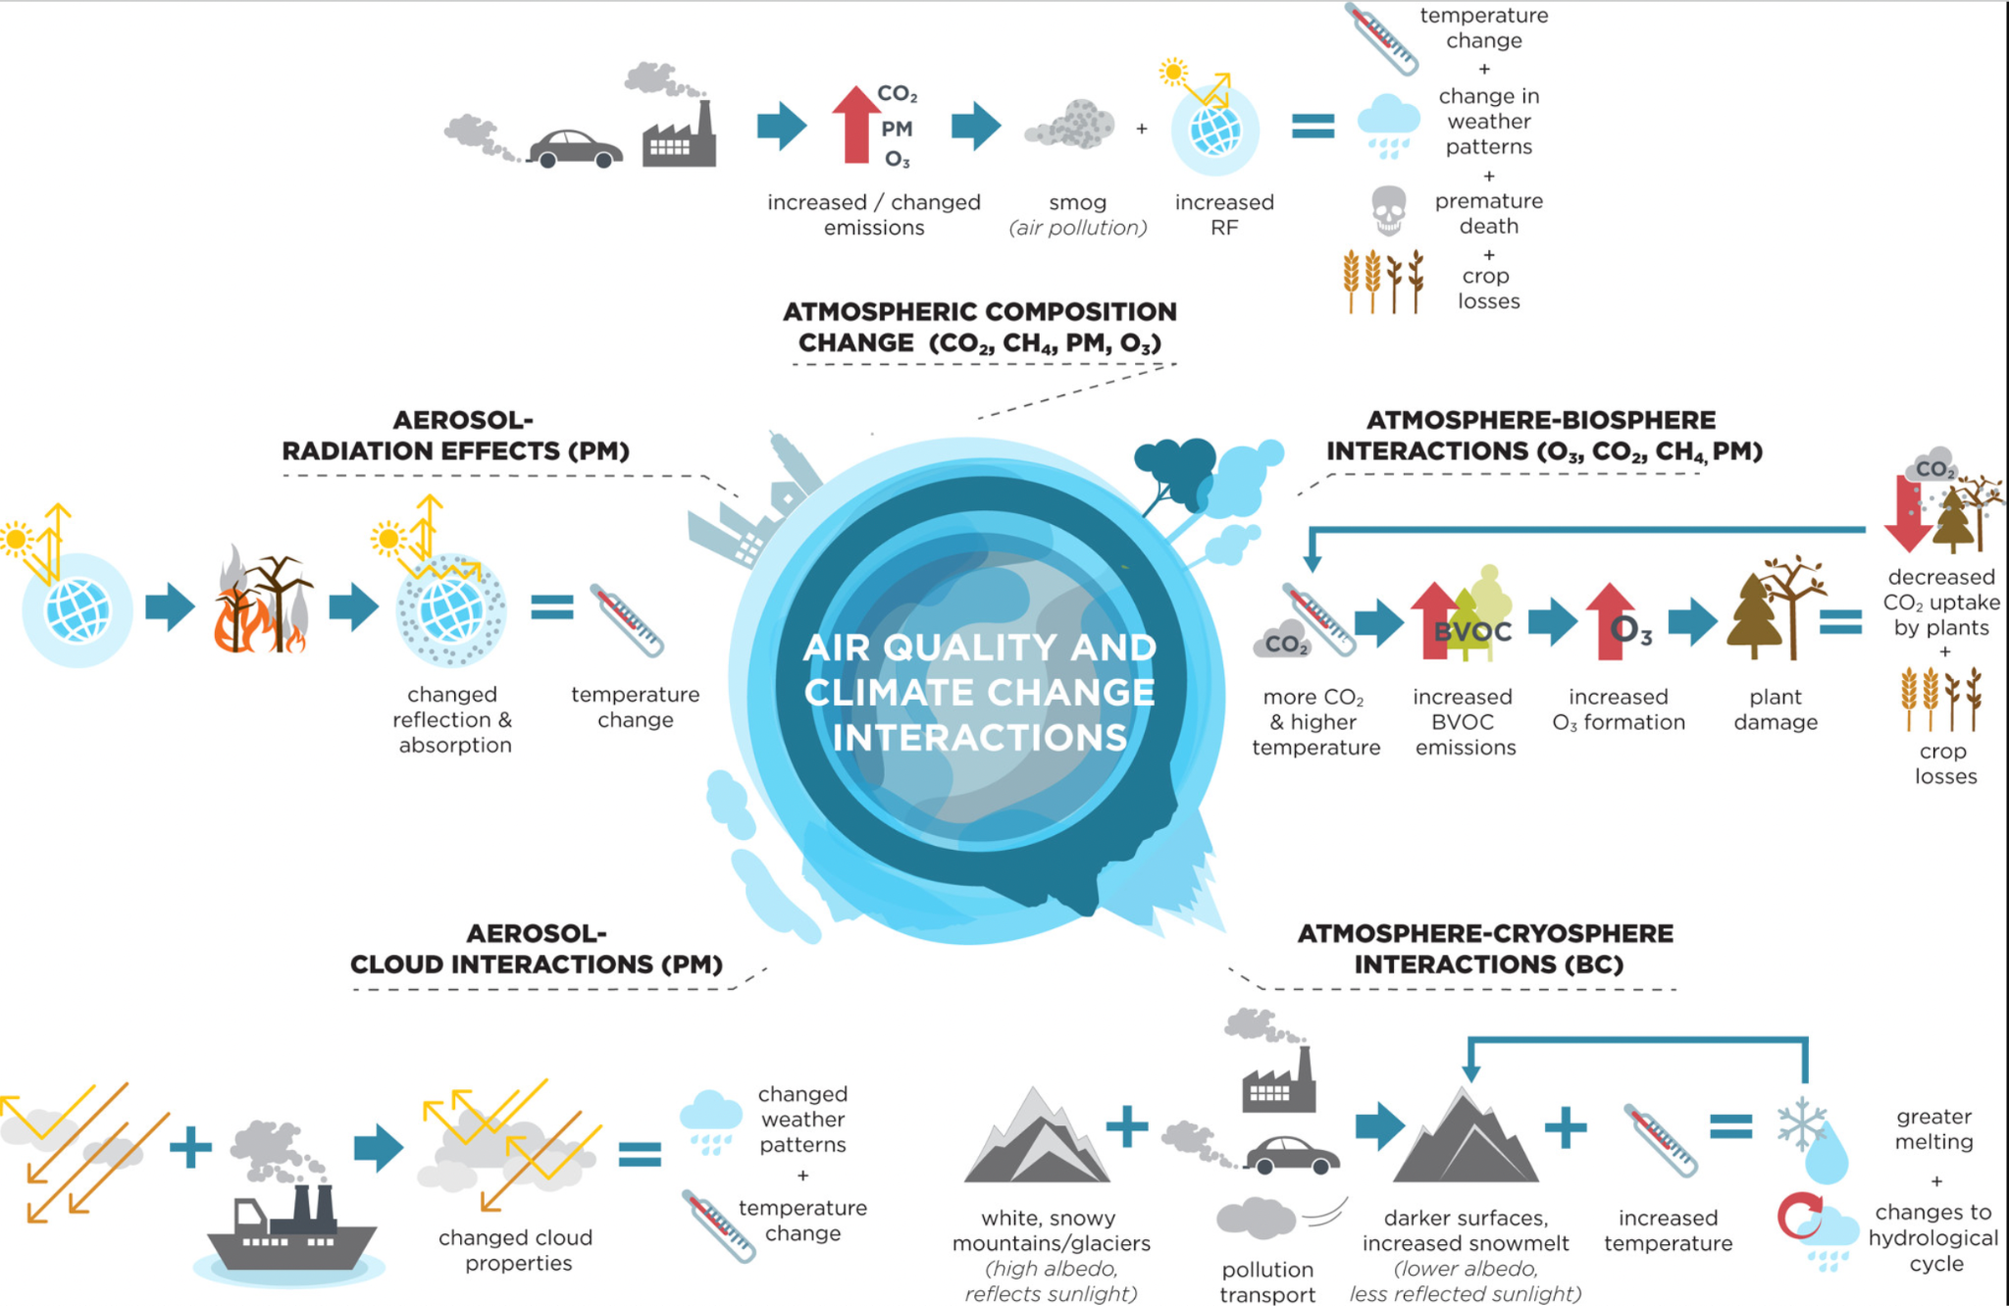

Interaction 1: ________________________________________________________________________________________________________________________________________________________________________________________________________________________________________________________________________________________________________________________________________________________________________________________________________________________________________________________________________________________________________________________________________________________________________________________________________________

Interaction 2:

__________________________________________________________________________

________________________________________________________________________________________________________________________________________________________________________________________________________________________________________________________________________________________________________________________________________________________________________________________________________________________________________________________________________________________________________________________________________________________________________________________________________________

# **How does air quality affect our community?**

* [According to the EPA](https://www.epa.gov/greenvehicles/fast-facts-transportation-greenhouse-gas-emissions), the transportation sector is the largest contributor to anthropogenic U.S. greenhouse gas (GHG) emissions.
* [According to California’s Air Resources Board (CARB)](https://ww2.arb.ca.gov/ghg-inventory-data), 38% of California's greenhouse gas emissions are due to transportation.

**How does vehicle emission affect health?**

As you watch this *Healthy Air Matters* YouTube video ([tinyurl.com/healthyairmatters](http://tinyurl.com/healthyairmatters)), answer the following questions:

1. What leads to vehicle emissions?

______________________________________________________________________________________________________________________________________________________________________________________________________________________________

1. How does ozone pollution affect health?

______________________________________________________________________________________________________________________________________________________________________________________________________________________________

1. Who are the people most affected by vehicle emissions?

______________________________________________________________________________________________________________________________________________________________________________________________________________________________

**Analyzing local urban air pollution data:**

BEACO2N is an innovative approach for monitoring greenhouse gases (GHGs) in urban areas. Instead of relying on a few sensitive instruments, BEACO2N uses a network of sensors called 'nodes' placed approximately 1 mile (2km) apart. While individual nodes may have lower precision, when combined, they create a detailed map of CO2 and air pollutants like NO, NO2, O3, CO, and PM (particulate matter), providing valuable information about urban air quality.

**Showcase of BEACO2N sensors: How did the Covid shutdown affect air quality in the Bay Area?**

As you watch this video about air quality during COVID-19 ([tinyurl.com/covidairqualityimpact](http://tinyurl.com/covidairqualityimpact)), answer the following questions:

1. What pollutants improved during the COVID shutdown that were talked about in the video?

______________________________________________________________________________________________________________________________________________________________________________________________________________________________

1. Select one (a or b): What could we use BEACO2N data to explain?
   1. How many people died during Covid?
   2. Quantifying CO2 emissions from industry and from cars.
2. Write a paragraph explaining what the Covid shutdown did to Bay Area air quality.  
   ______________________________________________________________________________________________________________________________________________________________________________________________________________________________________________________________________________________________________________________________________________________________________________________________________________________________

# **Environmental Justice**

**Inquire activity: What does environmental justice mean?**

1. **In the table, write different synonyms or definitions for the words “environment” and “justice”.**

ENVIRONMENT

_____________________________________________________________________________________________________________________________________________________________________________________________________________________________________________________________________________________________________________________________________________________________________________________________________________________________________________

JUSTICE

_____________________________________________________________________________________________________________________________________________________________________________________________________________________________________________________________________________________________________________________________________________________________________________________________________________________________________________

1. After watching the *Changes in transportation-related air pollution exposures by race-ethnicity, socioeconomic status* YouTube video ([tinyurl.com/environmentaljusticevideo](http://tinyurl.com/environmentaljusticevideo)), write a paragraph describing the definition of Environmental Justice:

________________________________________________________________________________________________________________________________________________________________________________________________________________________________________________________________________________________

____________________________________________________________________________________________________________________________________________

**Reading and presentation activity: Environmental (IN)justice**

**Learning Outcomes:**

* Begin to understand environmental injustice
* Learn about ways we can address environmental injustice today.
* Understand the benefits and implications of environmental decisions.

**Instructions:**

1. Make a group of 2-3 people.
2. Your teacher will assign an article for each group
3. Every groupmate read the articles using the [Avid Strategies for Critical Reading and Digital Marking of Text](https://avidopenaccess.org/resource/critical-reading-and-digital-marking-of-text/)
4. Discuss with your groupmates about how the article made you feel. Why did it make you feel this way?
5. Prepare a presentation:
   1. Poster or slide deck with voice-over
   2. Time: 5 minutes maximum
   3. In your presentation, summarize the article by answering questions such as…
      1. What claims are made in the article?
      2. What event or problem caused people to start taking action?
      3. Who was affected by pollution and why were they affected by pollution?
      4. What environmental decisions were made?
      5. Who benefits from the environmental decision?
6. Complete the table below using the other group's presentations.

| Article | What event or problem caused people to start taking action? | What environmental decisions were made? | Who is impacted? | How are they impacted? |
| --- | --- | --- | --- | --- |
| #1 [McClymonds high school students reunited in Oakland as officials wait for final air samples](https://edsource.org/2020/parents-voice-concerns-over-groundwater-contamination-at-mcclymonds-high-school-in-oakland/624253) |  |  |  |  |
| #[2 Oxnard, California: The City That Stopped A Gas Plant](https://www.huffpost.com/entry/oxnard-california-gas-plant_n_5cfeafdce4b0aab91c0a2f27?guccounter=1&guce_referrer=aHR0cHM6Ly9uZXdzLmdvb2dsZS5jb20v&guce_referrer_sig=AQAAAN0-2p860oohdPfdtZ6g8oDbJCBwcFZCeddoucR8KsRN5iBj_17Svu9xfkL3HT0H0sVsm0YQHIOkdEHC-Xut18eaKnpngvyJYqMtoG4Y6IedwQ86wPZx8s6PEoOFVeafMxouCukVsJRPPW8Rt77oIbkeb22KToXbA4Za3ymOGbS1) |  |  |  |  |
| #3 [Chevron’s ‘Black Lives Matter’ Tweet Prompts a Debate About Big Oil and Environmental Justice](https://insideclimatenews.org/news/20062020/chevron-black-lives-matter-twitter/) |  |  |  |  |
| #4 [People of Color and the Poor Disproportionately Exposed to Air Pollution, Study Finds](https://www.calhealthreport.org/2019/02/08/people-of-color-and-the-poor-disproportionately-exposed-to-air-pollution-study-finds/) |  |  |  |  |
| #5 [Big victory for Hunters Point activists / As PG&E closes its old, smoky power plant, the neighborhood breathes a sigh of relief](https://www.sfgate.com/news/article/Big-victory-for-Hunters-Point-activists-As-PG-E-2534998.php) |  |  |  |  |
| #6 [Lead Found in Children in Communities Near Former Exide Battery Plant in Vernon: USC Study](https://ktla.com/news/local-news/lead-found-in-children-in-communities-near-former-exide-battery-plant-in-vernon-usc-study/) |  |  |  |  |
| #7 [Coronavirus Has Reduced Air Pollution, But Not The Risk In Some San Diego Communities](https://www.kpbs.org/news/2020/jun/04/coronavirus-has-reduced-air-pollution-not-risk-som/) |  |  |  |  |
| #8 I[nequity in consumption of goods and services adds to racial–ethnic disparities in air pollution exposure](https://www.pnas.org/doi/10.1073/pnas.1818859116) |  |  |  |  |
| #9  [This article is more than 4 years old](https://www.theguardian.com/us-news/2019/apr/04/new-york-south-bronx-minorities-pollution-inequity)  ['Asthma alley': why minorities bear burden of pollution inequity caused by white people](https://www.theguardian.com/us-news/2019/apr/04/new-york-south-bronx-minorities-pollution-inequity) |  |  |  |  |
| #10  [Struggling to breathe in 48217, Michigan’s most toxic ZIP code](https://www.metrotimes.com/news/struggling-to-breathe-in-48217-michigans-most-toxic-zip-code-23542211) |  |  |  |  |

**History of Environmental Injustice in California: Redlining Maps**

**What is redlining?** Redlining is a practice through which federal and local governments and financing entities systematically deny public and private financial services to blacks and other people of color. This set of practices led to many of the environmental disparities we see affecting communities across the state today.

**How did this happen?** In the 1930s, the Home Owners’ Loan Corporation Act (HOLC) and the Federal Housing Administration (FHA) implemented housing policies and assessments that perpetuated environmental injustice by creating maps that redlined neighborhoods based on race and contributed to racial segregation and disparities in access to resources.

**Example of Mapping of inequality: from Albany to San Leandro**

The map from 1937 aimed to show that the area was “secure” enough to guarantee federal loans. Maps were color-coded. Neighborhoods found to be high risk to lenders were outlined in red, and neighborhoods deemed “declining” were outlined in yellow. The “best” and “desirable” neighborhoods were outlined in green and blue. This four-tier system, also known as “A, B, C, or D,” produced a hierarchy of credit risk ratings.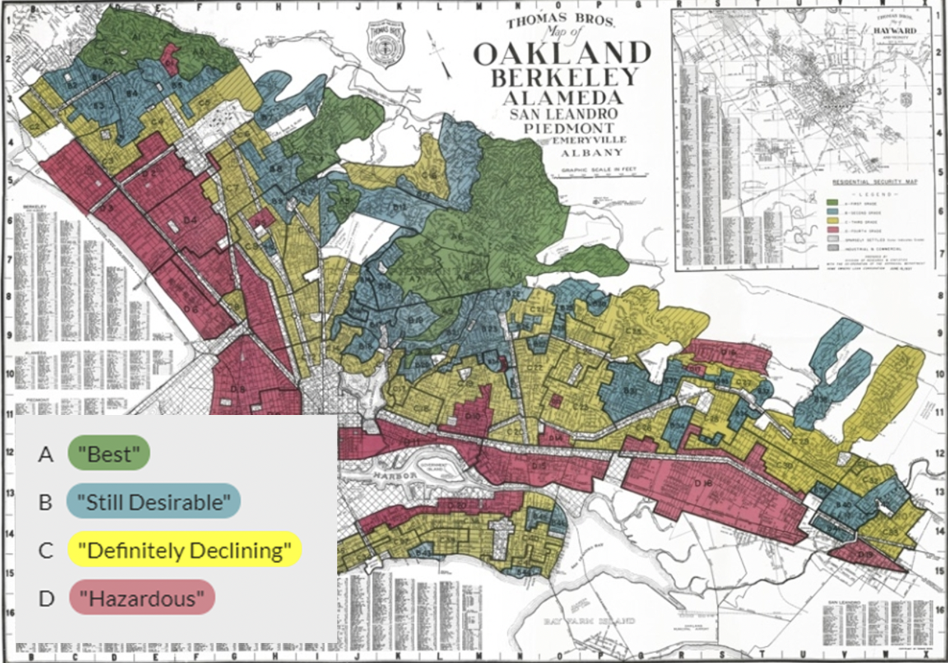

[The Mapping Inequality Tool](https://dsl.richmond.edu/panorama/redlining/#loc=5/39.1/-94.58)

[(tinyurl.com/mappinginequalitytool)](http://tinyurl.com/mappinginequalitytool)

* Click “map options” and then

“graded areas” to make it easier

to use.

* Click on an area and then click

“show scan” to see the primary

document with the data.

**Exploring vehicle pollutants**

NOX from vehicles is a harmful pollutant causing air pollution, smog, acid rain, and respiratory issues. It is a potent greenhouse gas, impacting climate change. Emission control measures are crucial for air quality.

Using our Google Colab Notebooks, we will visualize the NOX data from BEACO2N nodes to analyze and identify any trends present. When you’ve completed the **In Class** notebook (specificially Section 2: NOx Concentration Time Series), proceed to the next question.

1. Compare the BEACO2N data near/far from highways (in the notebook) to the redlining map from Albany and San Leandro above. Do you think that environmental injustice continues to perpetuate? Write a paragraph explaining your answer.

_______________________________________________________________________________________________________________________________________________________________________________________________________________________________________________________________________________________

______________________________________________________________________________________________________________________________________________________________________________________________________________________________________________________________________________________________________________________________________________________________